Math 109 – Investigating Inverse Functions

1. Let $f\left(x\right)$ be the function $f\left(x\right)={\left(x-2\right)}^{3}+3.$ Fill out the following data table and sketch the graph of the function.

|  |  |  |  |  |  |
| --- | --- | --- | --- | --- | --- |
| $$x$$ | 0 | 1 | 2 | 3 | 4 |
| $$y$$ |  |  |  |  |  |

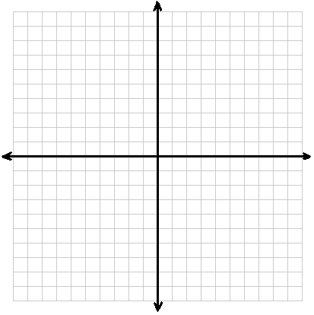

1. We want to find the *inverse* of this function. The symbol for the inverse function is $f^{-1}\left(x\right).$ An inverse function “un-does” the function. For example, we know that with this function 0 is mapped to -5. For the inverse function, we want -5 to map to 0. Fill out the following table of values for the inverse function.

|  |  |  |  |  |  |
| --- | --- | --- | --- | --- | --- |
| $$x$$ | -5 |  |  |  |  |
| $$y$$ | 0 |  |  |  |  |

1. Plot these points on the graph above and use them to graph the inverse function. Do you see any similarities in the graph of $f(x)$ and ${ f}^{-1}(x)$? How are the two graphs related?
2. Notice that to find the inverse function, you switched the $x$ and $y$ values of both the data and the graph. Use the same method to find the inverse using the formula for the function. Take the equation

$y={\left(x-2\right)}^{3}+3$ and switch the $x$ and $y$ values. Then solve for the new $y$. This is the equation of the inverse function.

1. Does every function have an inverse function? Can you think of any reason a function might not have an inverse function?